# Japan results

## Cluster results

We used 3 clustering methods to group Japanese dataset-Kmeans, GMM and LPA. Each of them shows different strengths and shortcomings.

1. Kmeans

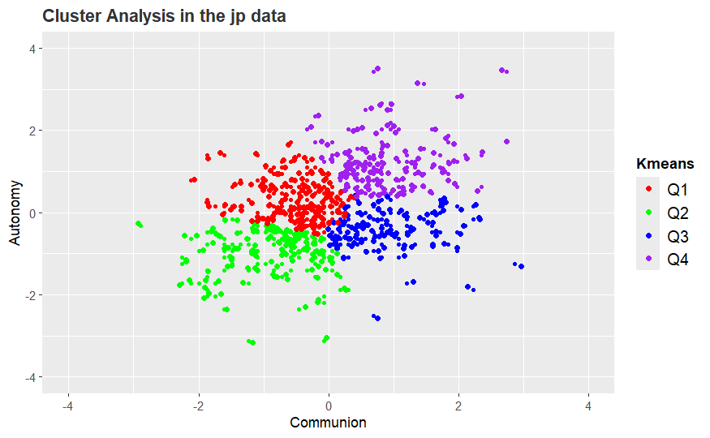

1. GMM

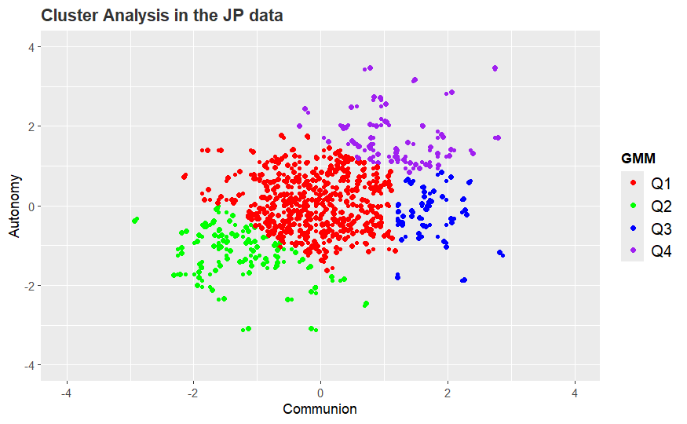

1. LPA

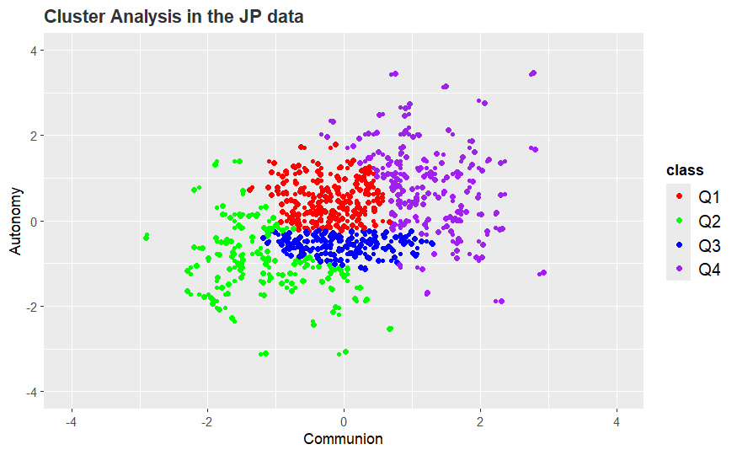

Based on the previous research, we chose Kmeans to do later analyisis.

## Cluster group results

We divided the Japanese dataset into 3 groups according to their age: YOUNGEST 20-36; MIDDLE 37-45; OLDEST 46 AND ABOVE. And the group clustering results are as follows:

1. Young

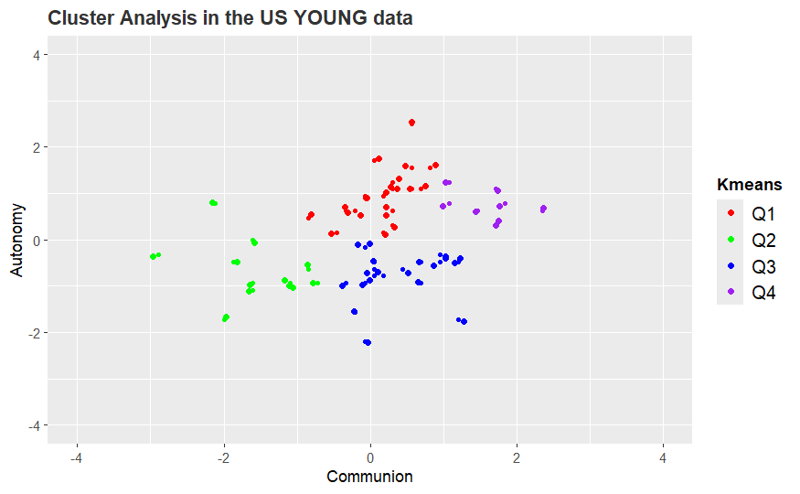

1. Middle

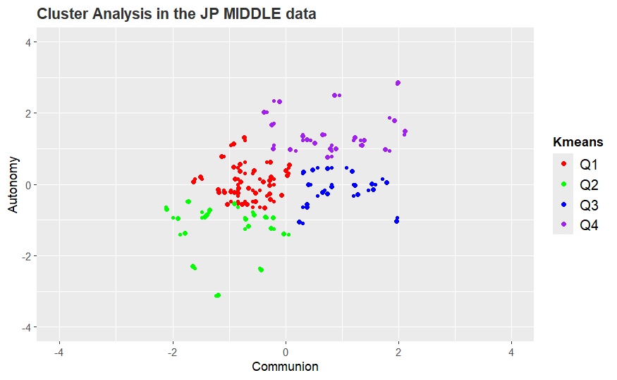

1. Old

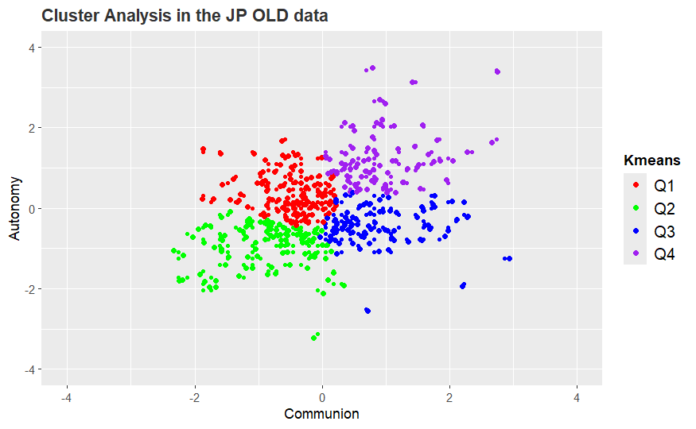

1. Comparison of centers

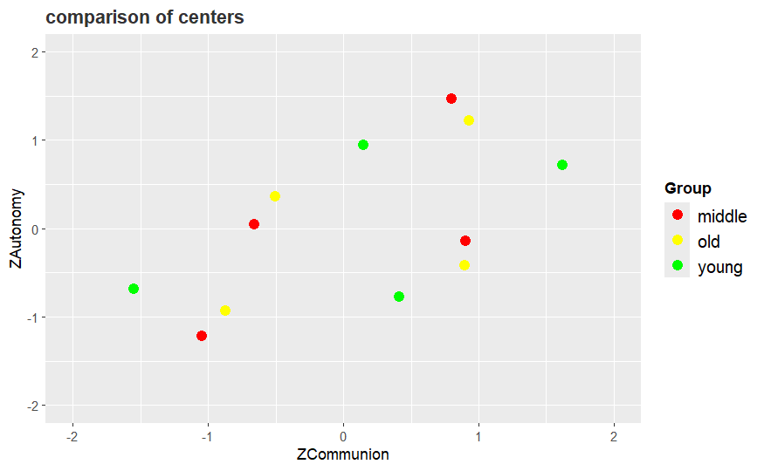

## Elbow method and ASW

1. Overall

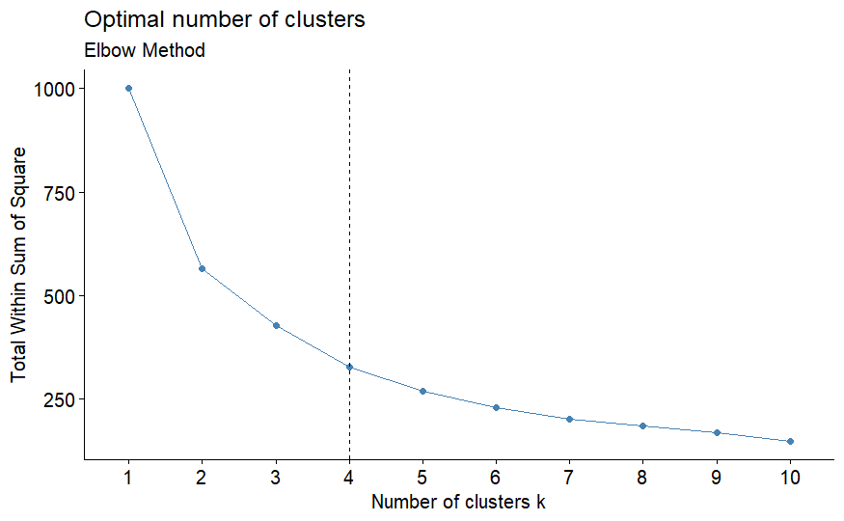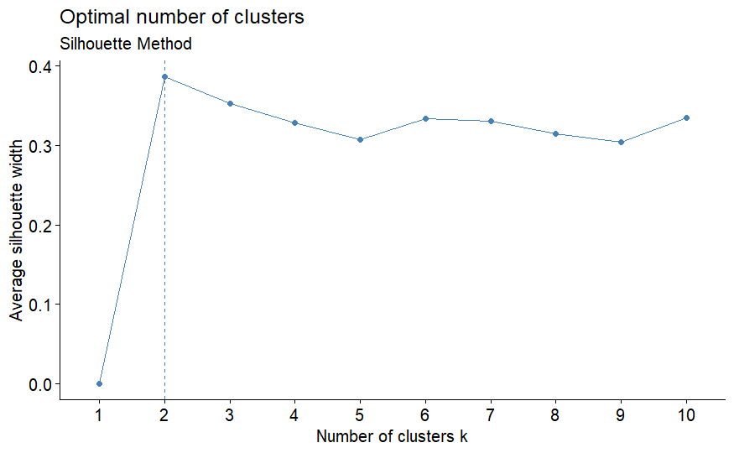

Number of clusters: 2 Average Silhouette Width: 0.3815289

Number of clusters: 3 Average Silhouette Width: 0.3495681

Number of clusters: 4 Average Silhouette Width: 0.3299155

Number of clusters: 5 Average Silhouette Width: 0.3287453

Number of clusters: 6 Average Silhouette Width: 0.3309049

Number of clusters: 7 Average Silhouette Width: 0.3327689

Number of clusters: 8 Average Silhouette Width: 0.3434125

Number of clusters: 9 Average Silhouette Width: 0.3328229

Number of clusters: 10 Average Silhouette Width: 0.3355457

1. Young

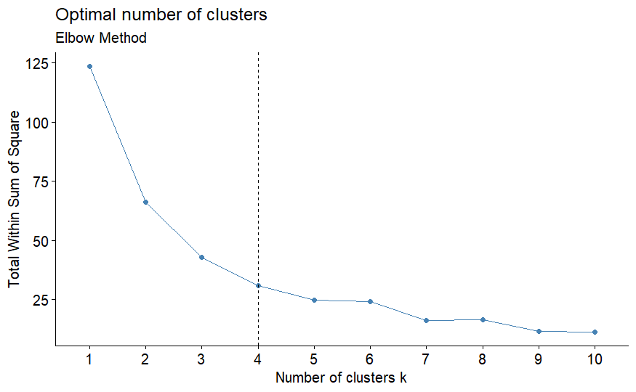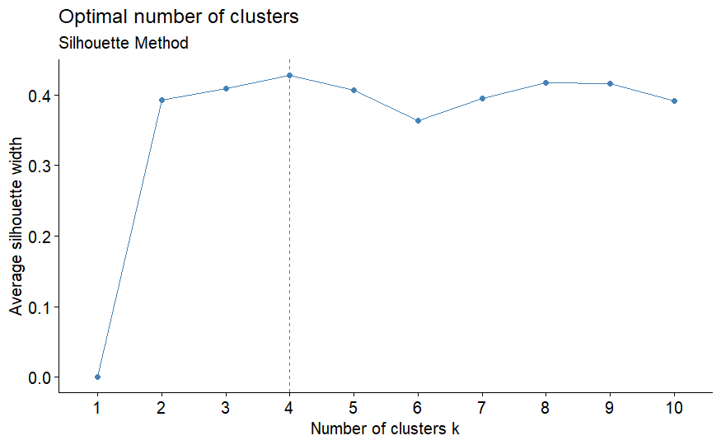

Number of clusters: 2 Average Silhouette Width: 0.3934016

Number of clusters: 3 Average Silhouette Width: 0.4092919

Number of clusters: 4 Average Silhouette Width: 0.4282703

Number of clusters: 5 Average Silhouette Width: 0.4070163

Number of clusters: 6 Average Silhouette Width: 0.4027752

Number of clusters: 7 Average Silhouette Width: 0.4097197

Number of clusters: 8 Average Silhouette Width: 0.4179557

Number of clusters: 9 Average Silhouette Width: 0.4162042

Number of clusters: 10 Average Silhouette Width: 0.3910863

1. Middle

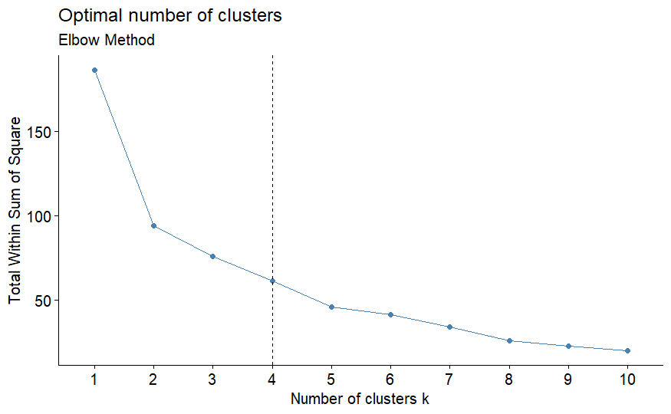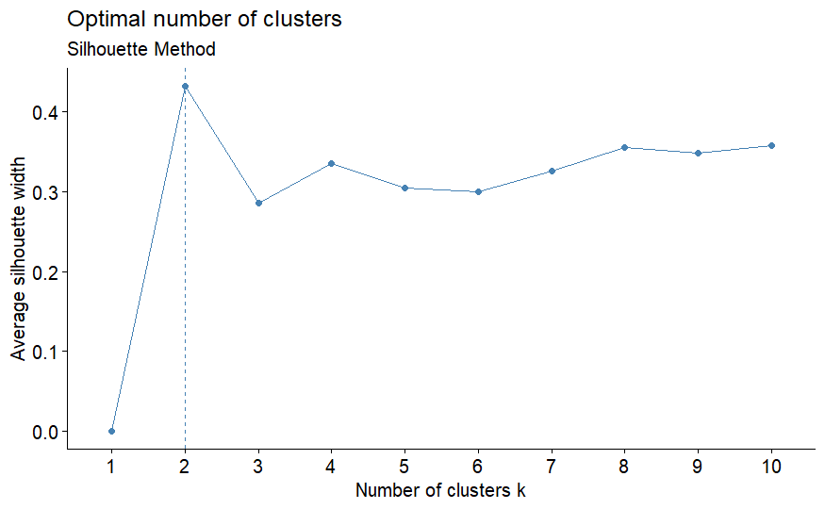

Number of clusters: 2 Average Silhouette Width: 0.4322387

Number of clusters: 3 Average Silhouette Width: 0.331006

Number of clusters: 4 Average Silhouette Width: 0.3363618

Number of clusters: 5 Average Silhouette Width: 0.3490055

Number of clusters: 6 Average Silhouette Width: 0.3401529

Number of clusters: 7 Average Silhouette Width: 0.3471159

Number of clusters: 8 Average Silhouette Width: 0.3580994

Number of clusters: 9 Average Silhouette Width: 0.3605575

Number of clusters: 10 Average Silhouette Width: 0.3616212

1. Old

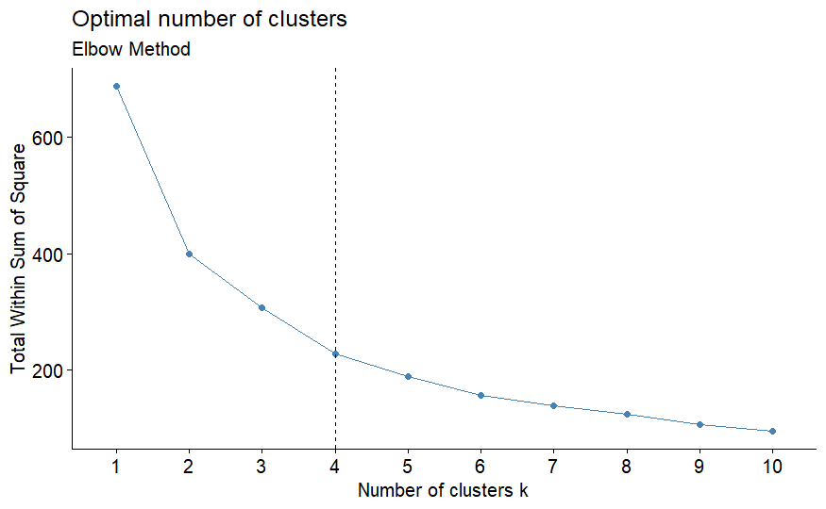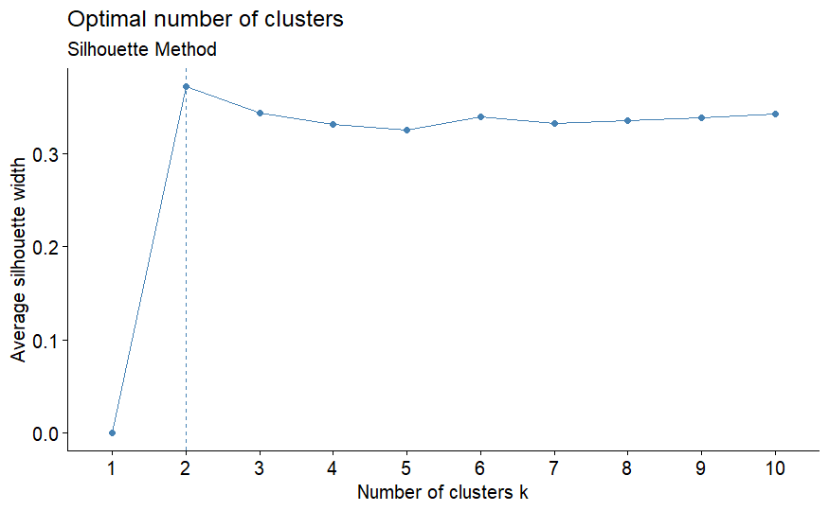

Number of clusters: 2 Average Silhouette Width: 0.3724213

Number of clusters: 3 Average Silhouette Width: 0.345509

Number of clusters: 4 Average Silhouette Width: 0.331001

Number of clusters: 5 Average Silhouette Width: 0.3305676

Number of clusters: 6 Average Silhouette Width: 0.3399422

Number of clusters: 7 Average Silhouette Width: 0.3429694

Number of clusters: 8 Average Silhouette Width: 0.3553224

Number of clusters: 9 Average Silhouette Width: 0.3594882

Number of clusters: 10 Average Silhouette Width: 0.3448599

1. Conclusion

We can conclude that in young and old group, Elbow methods show the best at 4 clusters. While in middle group, ASW shows the best at 4 clusters.

## ANOVA test

1. PosMinusnegaffect

ALL

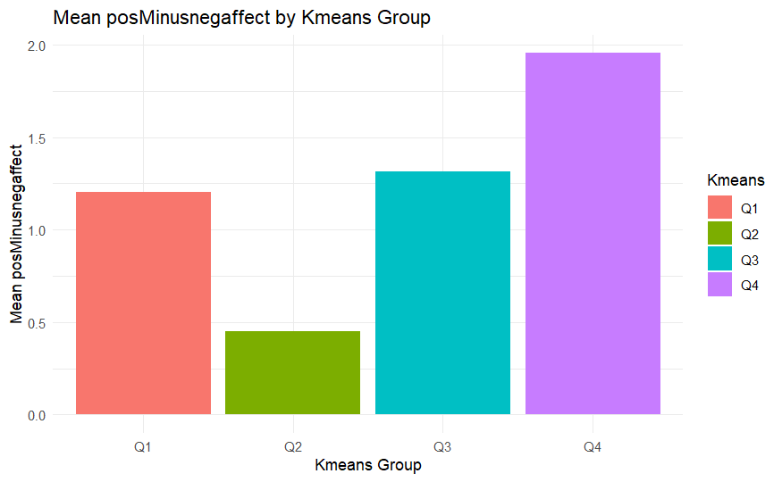 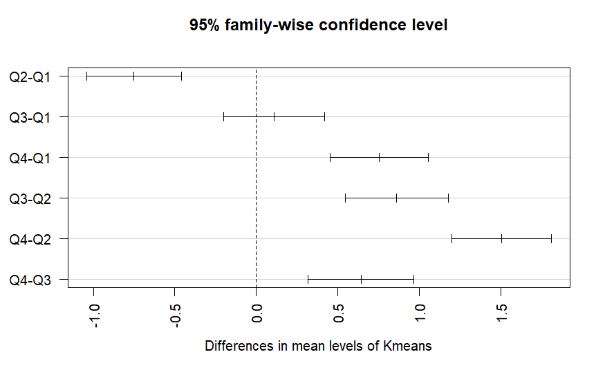

$Kmeans

diff lwr upr p adj

Q2-Q1 -0.7515954 -1.0415773 -0.4616135 0.0000000

Q3-Q1 0.1101829 -0.1987678 0.4191337 0.7945764

Q4-Q1 0.7528311 0.4522488 1.0534133 0.0000000

Q3-Q2 0.8617783 0.5471299 1.1764268 0.0000000

Q4-Q2 1.5044265 1.1979909 1.8108620 0.0000000

Q4-Q3 0.6426481 0.3182043 0.9670920 0.0000028

YOUNG

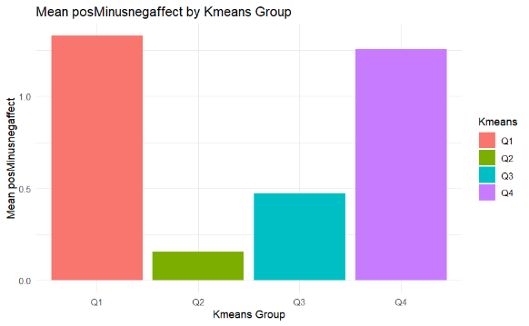 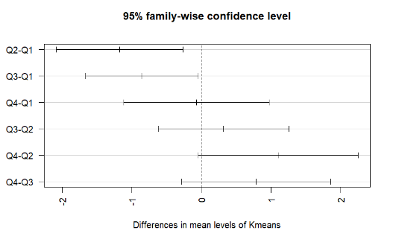

$Kmeans

diff lwr upr p adj

Q2-Q1 -1.17440476 -2.0851159 -0.26369367 0.0064047

Q3-Q1 -0.85634921 -1.6647195 -0.04797894 0.0339069

Q4-Q1 -0.07232143 -1.1179280 0.97328509 0.9977894

Q3-Q2 0.31805556 -0.6198469 1.25595802 0.8056637

Q4-Q2 1.10208333 -0.0466079 2.25077457 0.0644972

Q4-Q3 0.78402778 -0.2853456 1.85340112 0.2226231

MIDDLE

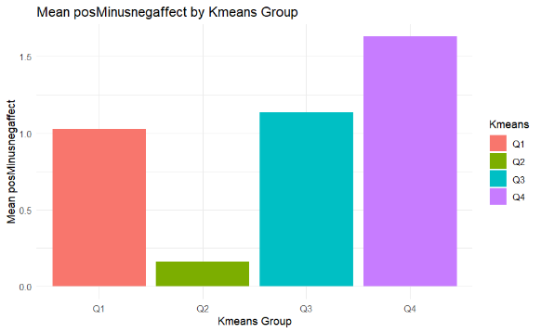 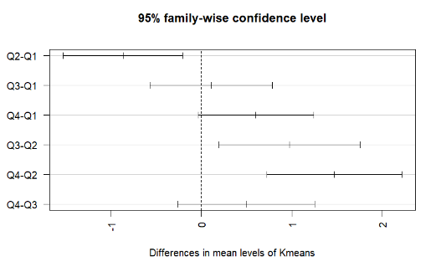

$Kmeans

diff lwr upr p adj

Q2-Q1 -0.8659159 -1.52747116 -0.2043607 0.0050473

Q3-Q1 0.1082671 -0.56625075 0.7827849 0.9748645

Q4-Q1 0.6029730 -0.03594257 1.2418885 0.0715449

Q3-Q2 0.9741830 0.19561744 1.7527486 0.0080491

Q4-Q2 1.4688889 0.72095634 2.2168214 0.0000096

Q4-Q3 0.4947059 -0.26471632 1.2541281 0.3267805

OLD

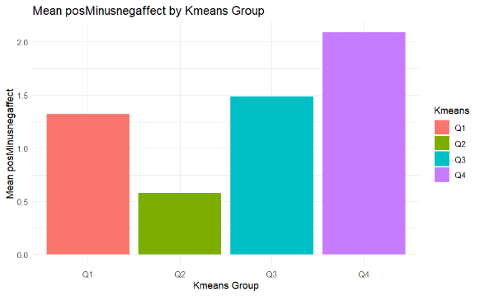 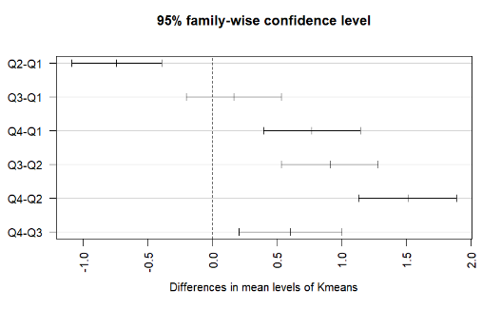

$Kmeans

diff lwr upr p adj

Q2-Q1 -0.7419079 -1.0894347 -0.3943812 0.0000004

Q3-Q1 0.1665643 -0.2015915 0.5347200 0.6475729

Q4-Q1 0.7702222 0.3966081 1.1438362 0.0000011

Q3-Q2 0.9084722 0.5355234 1.2814211 0.0000000

Q4-Q2 1.5121301 1.1337921 1.8904681 0.0000000

Q4-Q3 0.6036579 0.2062872 1.0010286 0.0006096

1. J1SSATIS

ALL

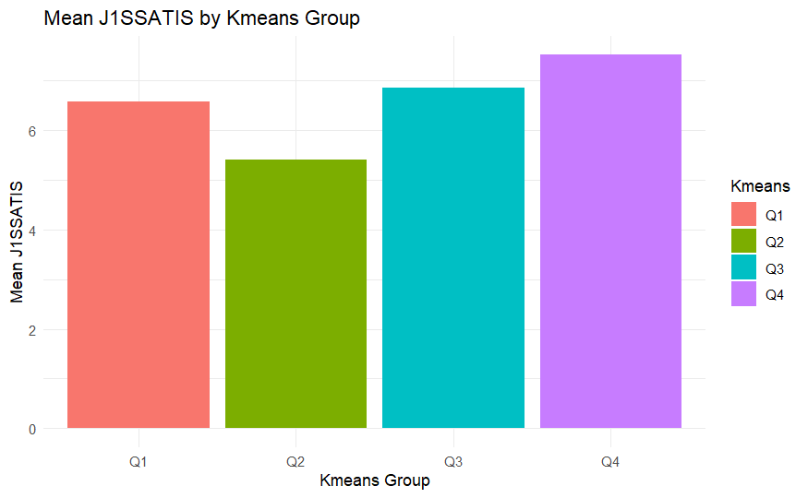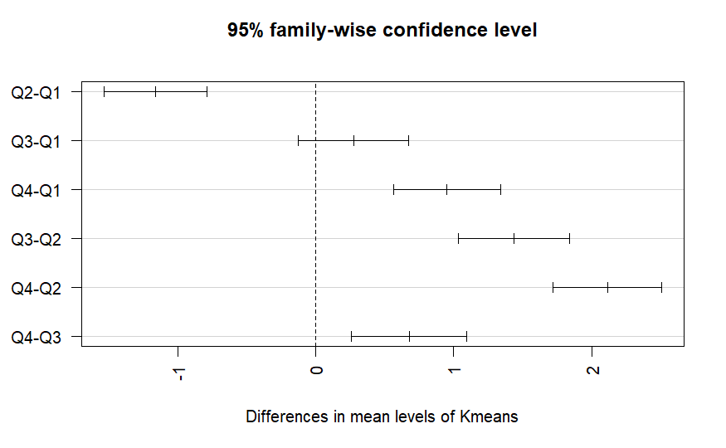

$Kmeans

diff lwr upr p adj

Q2-Q1 -1.1646616 -1.5382937 -0.7910296 0.0000000

Q3-Q1 0.2725216 -0.1253272 0.6703703 0.2912328

Q4-Q1 0.9495663 0.5614916 1.3376410 0.0000000

Q3-Q2 1.4371832 1.0320400 1.8423264 0.0000000

Q4-Q2 2.1142279 1.7186785 2.5097774 0.0000000

Q4-Q3 0.6770447 0.2585449 1.0955445 0.0002092

YOUNG

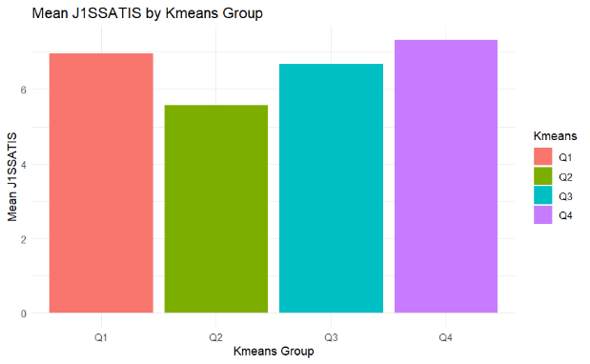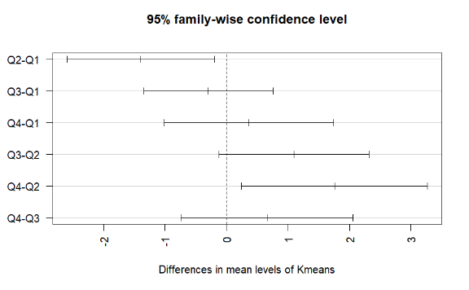

$Kmeans

diff lwr upr p adj

Q2-Q1 -1.3913690 -2.5907754 -0.1919627 0.0168191

Q3-Q1 -0.2932331 -1.3426624 0.7561963 0.8805547

Q4-Q1 0.3638393 -1.0132244 1.7409029 0.8967974

Q3-Q2 1.0981360 -0.1240100 2.3202819 0.0929213

Q4-Q2 1.7552083 0.2423821 3.2680345 0.0167985

Q4-Q3 0.6570724 -0.7398419 2.0539866 0.6009595

MIDDLE

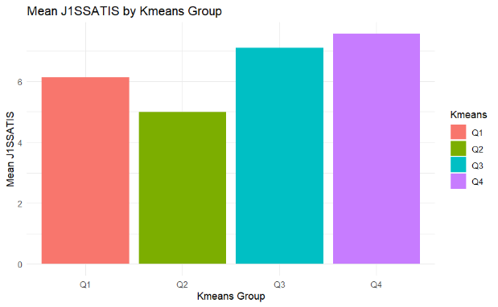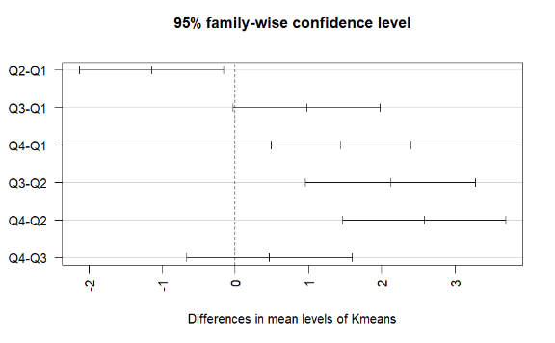

$Kmeans

diff lwr upr p adj

Q2-Q1 -1.1424550 -2.12906111 -0.1558488 0.0165205

Q3-Q1 0.9739666 -0.03197123 1.9799045 0.0613680

Q4-Q1 1.4408784 0.48803579 2.3937210 0.0008604

Q3-Q2 2.1164216 0.95531281 3.2775303 0.0000419

Q4-Q2 2.5833333 1.46790894 3.6987577 0.0000002

Q4-Q3 0.4669118 -0.66564765 1.5994712 0.7028175

OLD

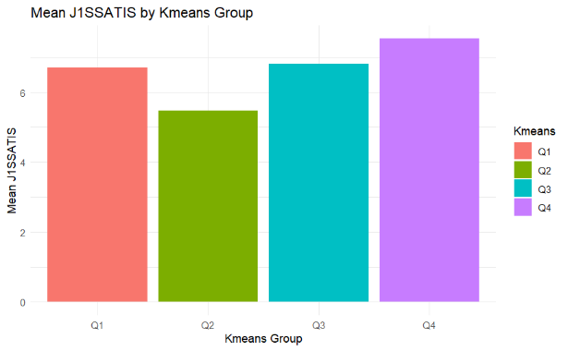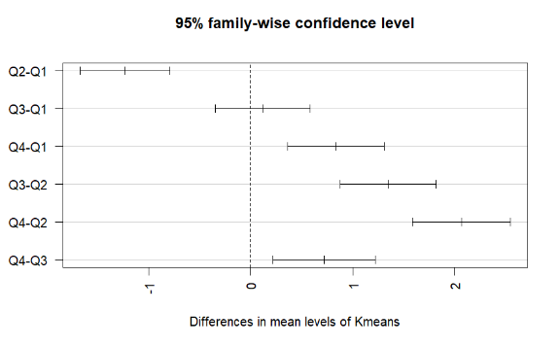

$Kmeans

diff lwr upr p adj

Q2-Q1 -1.2304892 -1.6702324 -0.7907461 0.0000000

Q3-Q1 0.1178362 -0.3464845 0.5821570 0.9137364

Q4-Q1 0.8365827 0.3636834 1.3094820 0.0000404

Q3-Q2 1.3483255 0.8769480 1.8197030 0.0000000

Q4-Q2 2.0670719 1.5872420 2.5469018 0.0000000

Q4-Q3 0.7187464 0.2162960 1.2211969 0.0014605

1. J1SPWBG1

ALL

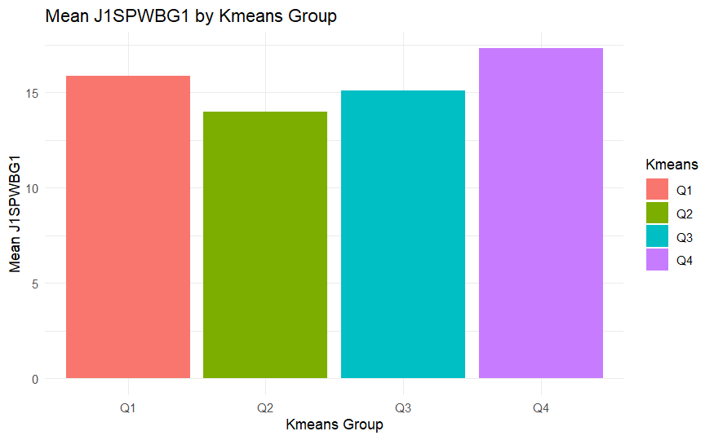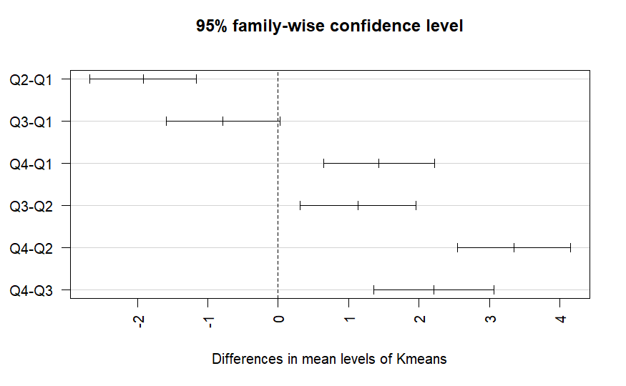

$Kmeans

diff lwr upr p adj

Q2-Q1 -1.9181649 -2.6784299 -1.1578999 0.0000000

Q3-Q1 -0.7825257 -1.5920667 0.0270153 0.0624237

Q4-Q1 1.4309120 0.6412592 2.2205647 0.0000228

Q3-Q2 1.1356392 0.3112555 1.9600229 0.0023653

Q4-Q2 3.3490769 2.5442145 4.1539392 0.0000000

Q4-Q3 2.2134377 1.3618761 3.0649993 0.0000000

YOUNG

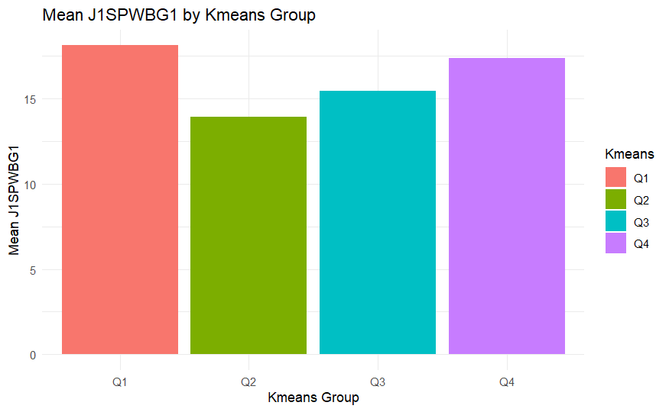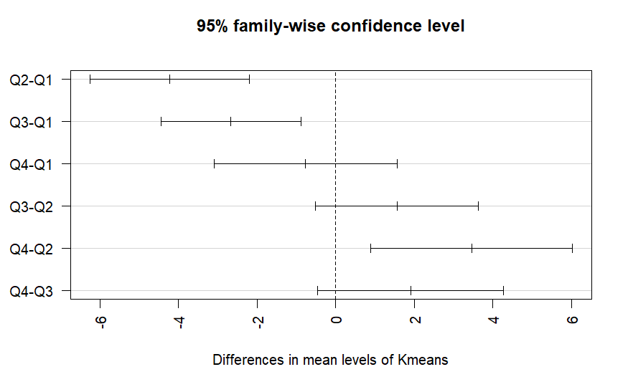

$Kmeans

diff lwr upr p adj

Q2-Q1 -4.2261905 -6.2592428 -2.193138 0.0000056

Q3-Q1 -2.6691729 -4.4480069 -0.890339 0.0011450

Q4-Q1 -0.7678571 -3.1020472 1.566333 0.8197383

Q3-Q2 1.5570175 -0.5145795 3.628615 0.2039452

Q4-Q2 3.4583333 0.8940191 6.022648 0.0040079

Q4-Q3 1.9013158 -0.4665220 4.269154 0.1574108

MIDDLE

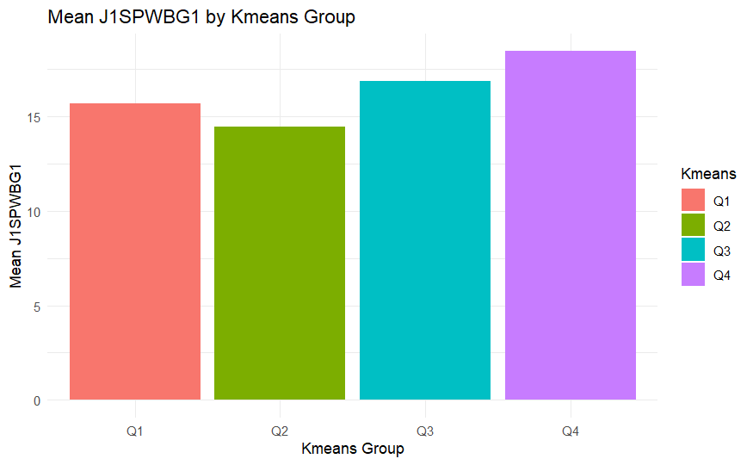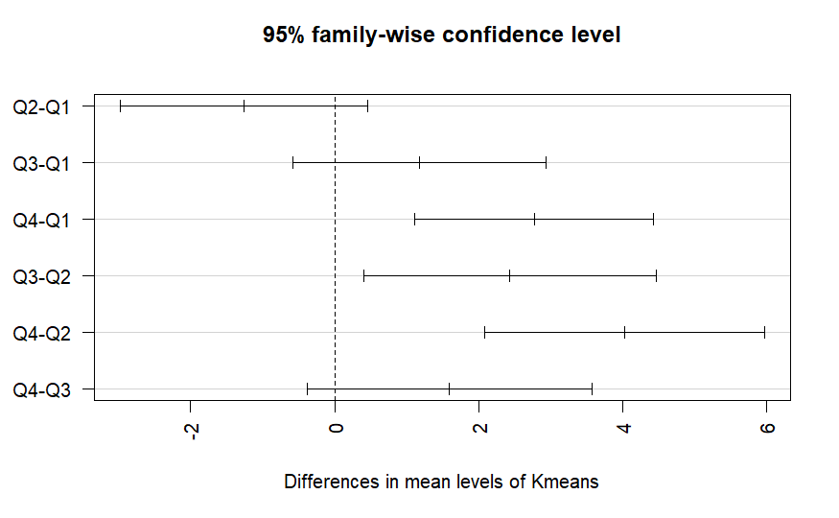

$Kmeans

diff lwr upr p adj

Q2-Q1 -1.258258 -2.9820129 0.4654964 0.2306759

Q3-Q1 1.179650 -0.5778799 2.9371804 0.3006498

Q4-Q1 2.772297 1.1075328 4.4370618 0.0002026

Q3-Q2 2.437908 0.4092706 4.4665464 0.0118562

Q4-Q2 4.030556 2.0817353 5.9793758 0.0000031

Q4-Q3 1.592647 -0.3861107 3.5714048 0.1586462

OLD

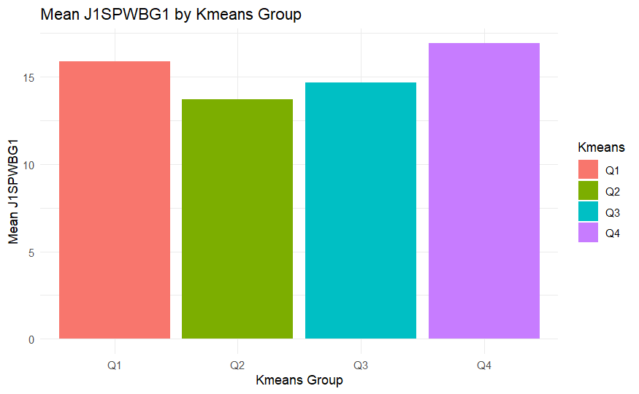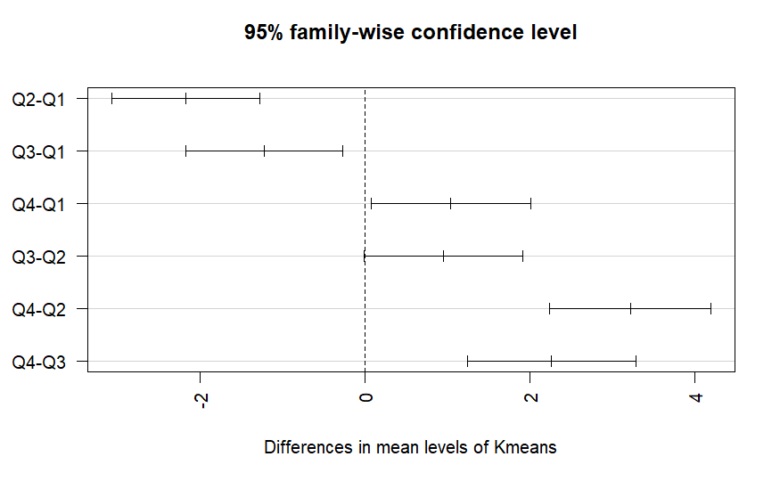

$Kmeans

diff lwr upr p adj

Q2-Q1 -2.1753383 -3.07465583 -1.2760207 0.0000000

Q3-Q1 -1.2230375 -2.17261852 -0.2734565 0.0053798

Q4-Q1 1.0436941 0.07656910 2.0108192 0.0286587

Q3-Q2 0.9523008 -0.01171204 1.9163136 0.0542450

Q4-Q2 3.2190324 2.23773357 4.2003313 0.0000000

Q4-Q3 2.2667316 1.23917165 3.2942916 0.0000002

1. J1SPWBU1

ALL

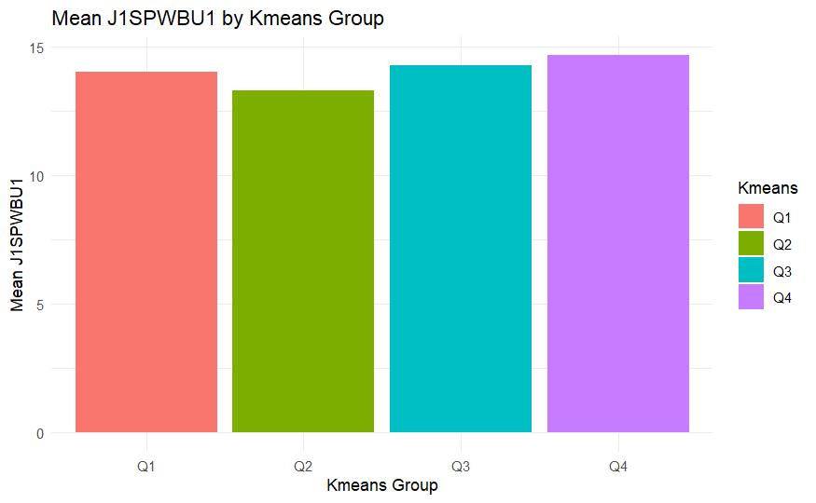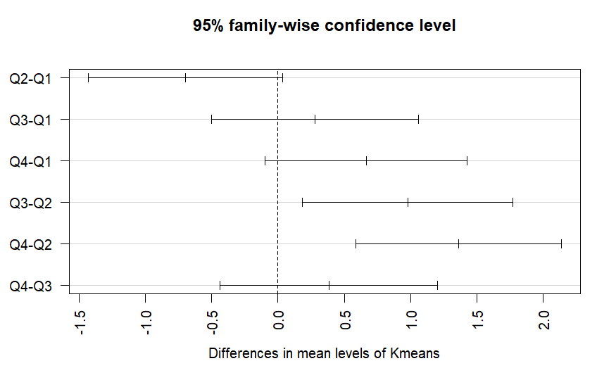

$Kmeans

diff lwr upr p adj

Q2-Q1 -0.6967864 -1.42976803 0.03619531 0.0692367

Q3-Q1 0.2810480 -0.49944140 1.06153733 0.7897728

Q4-Q1 0.6647115 -0.09660332 1.42602637 0.1113006

Q3-Q2 0.9778343 0.18303491 1.77263374 0.0087219

Q4-Q2 1.3614979 0.58551930 2.13747647 0.0000450

Q4-Q3 0.3836636 -0.43733844 1.20466555 0.6242563

YOUNG

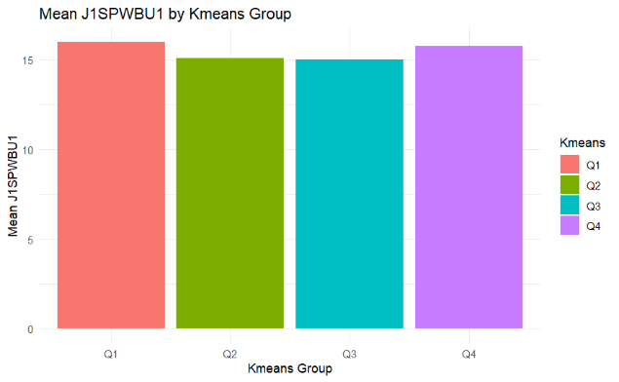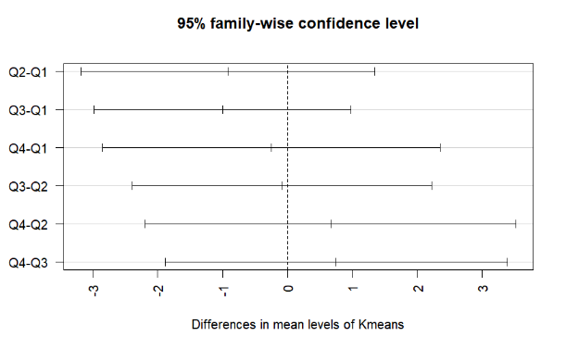

$Kmeans

diff lwr upr p adj

Q2-Q1 -0.91666667 -3.179900 1.3465664 0.7075769

Q3-Q1 -1.00000000 -2.980232 0.9802323 0.5435812

Q4-Q1 -0.25000000 -2.848465 2.3484654 0.9941343

Q3-Q2 -0.08333333 -2.389475 2.2228085 0.9996823

Q4-Q2 0.66666667 -2.187977 3.5213107 0.9257893

Q4-Q3 0.75000000 -1.885923 3.3859227 0.8748297

MIDDLE

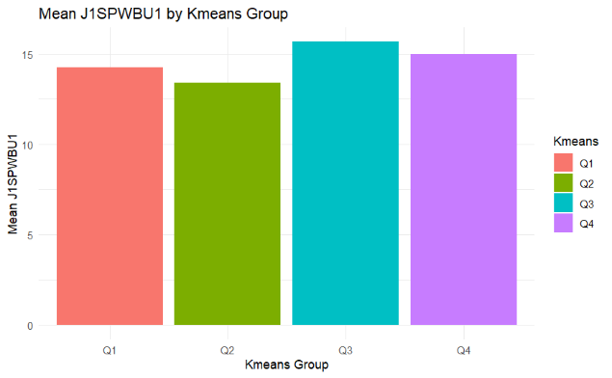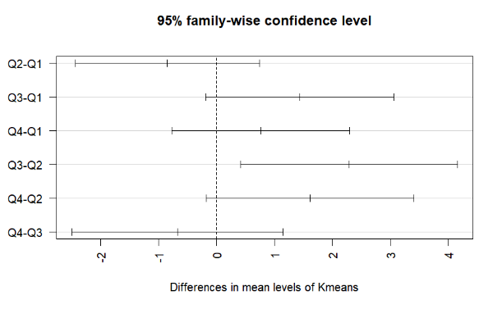

$Kmeans

diff lwr upr p adj

Q2-Q1 -0.8543544 -2.4438495 0.7351408 0.4980286

Q3-Q1 1.4332273 -0.1874126 3.0538672 0.1021688

Q4-Q1 0.7567568 -0.7783428 2.2918563 0.5710844

Q3-Q2 2.2875817 0.4169500 4.1582134 0.0100641

Q4-Q2 1.6111111 -0.1859197 3.4081419 0.0951466

Q4-Q3 -0.6764706 -2.5011072 1.1481660 0.7663011

OLD

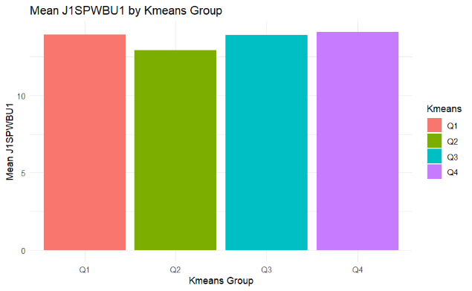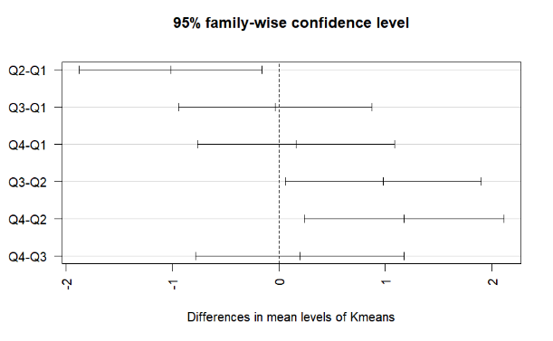

$Kmeans

diff lwr upr p adj

Q2-Q1 -1.01543739 -1.8741330 -0.1567418 0.0129841

Q3-Q1 -0.03563941 -0.9423281 0.8710492 0.9996256

Q4-Q1 0.16099801 -0.7624422 1.0844382 0.9695977

Q3-Q2 0.97979798 0.0593294 1.9002666 0.0318880

Q4-Q2 1.17643541 0.2394616 2.1134092 0.0071077

Q4-Q3 0.19663743 -0.7845079 1.1777828 0.9549193

1. J1SPWBS1

ALL

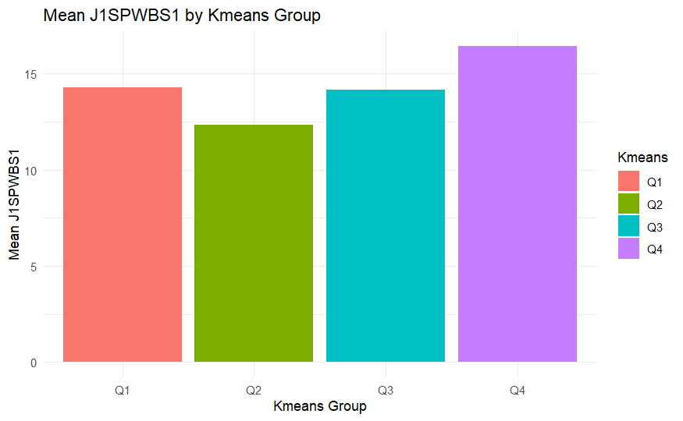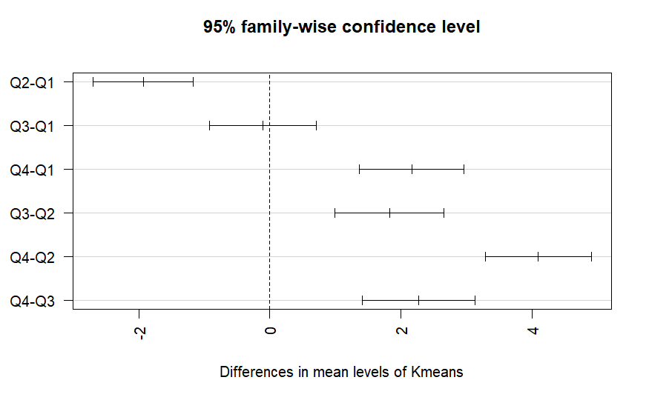

$Kmeans

diff lwr upr p adj

Q2-Q1 -1.9321021 -2.6981050 -1.1660992 0.0000000

Q3-Q1 -0.1100302 -0.9256810 0.7056206 0.9855501

Q4-Q1 2.1618070 1.3661945 2.9574195 0.0000000

Q3-Q2 1.8220719 0.9914664 2.6526775 0.0000002

Q4-Q2 4.0939091 3.2829723 4.9048459 0.0000000

Q4-Q3 2.2718372 1.4138486 3.1298257 0.0000000

YOUNG

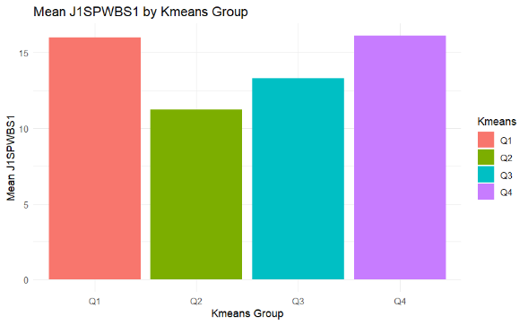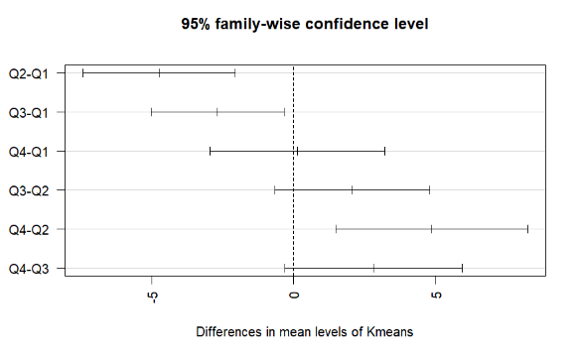

$Kmeans

diff lwr upr p adj

Q2-Q1 -4.750000 -7.4335415 -2.0664585 0.0001049

Q3-Q1 -2.684211 -5.0321947 -0.3362264 0.0189756

Q4-Q1 0.125000 -2.9560303 3.2060303 0.9995508

Q3-Q2 2.065789 -0.6686294 4.8002083 0.2001245

Q4-Q2 4.875000 1.4902157 8.2597843 0.0018997

Q4-Q3 2.809211 -0.3162334 5.9346544 0.0927655

MIDDLE

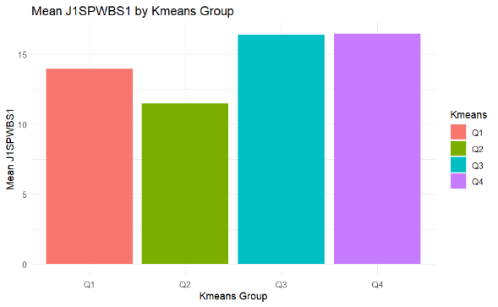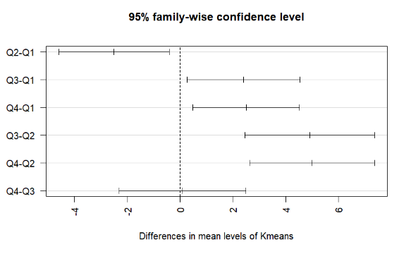

$Kmeans

diff lwr upr p adj

Q2-Q1 -2.50150150 -4.5922195 -0.4107835 0.0123456

Q3-Q1 2.40699523 0.2753114 4.5386790 0.0204348

Q4-Q1 2.50405405 0.4848845 4.5232237 0.0087898

Q3-Q2 4.90849673 2.4479901 7.3690034 0.0000069

Q4-Q2 5.00555556 2.6418587 7.3692524 0.0000018

Q4-Q3 0.09705882 -2.3029489 2.4970665 0.9995716

OLD

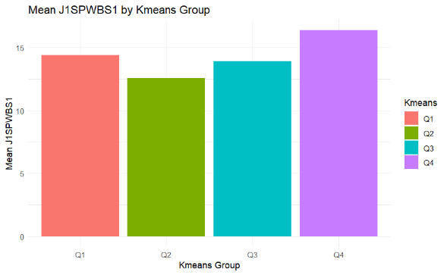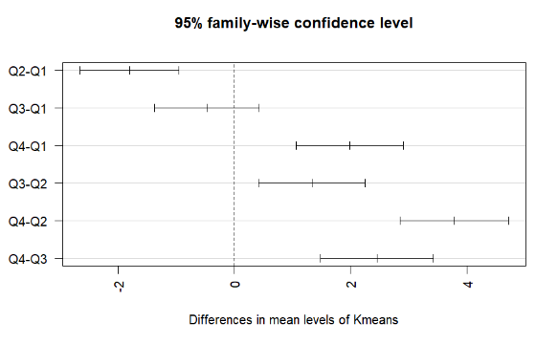

$Kmeans

diff lwr upr p adj

Q2-Q1 -1.802268 -2.6552971 -0.9492388 0.0000006

Q3-Q1 -0.466690 -1.3673955 0.4340156 0.5397058

Q4-Q1 1.987339 1.0699920 2.9046852 0.0000003

Q3-Q2 1.335578 0.4211834 2.2499726 0.0010908

Q4-Q2 3.789607 2.8588157 4.7203975 0.0000000

Q4-Q3 2.454029 1.4793577 3.4286995 0.0000000

Ps: I highlighted all the none significant comparison with red